**CAP785: WEB PERFORMANCE OPTIMIZATION**

**CONTINUOUS ASSESSMENTS (C.A)-1**

**ST_NAME : - EKHLAKH AHMAD**

**REG NO. : - 12209166**

**ROLL NO. : - 65**

**GROUP : - 2**

**Page Speed Without Optimization**

<https://ekhlakh-personal-portfolio.netlify.app/>

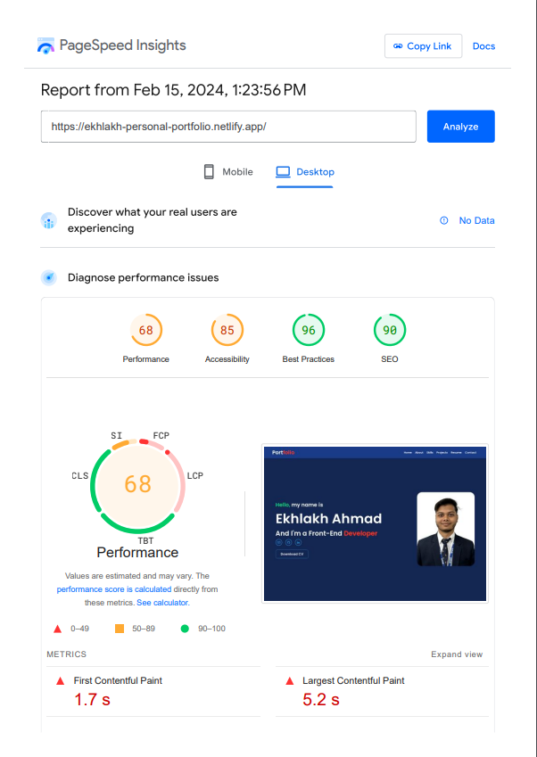

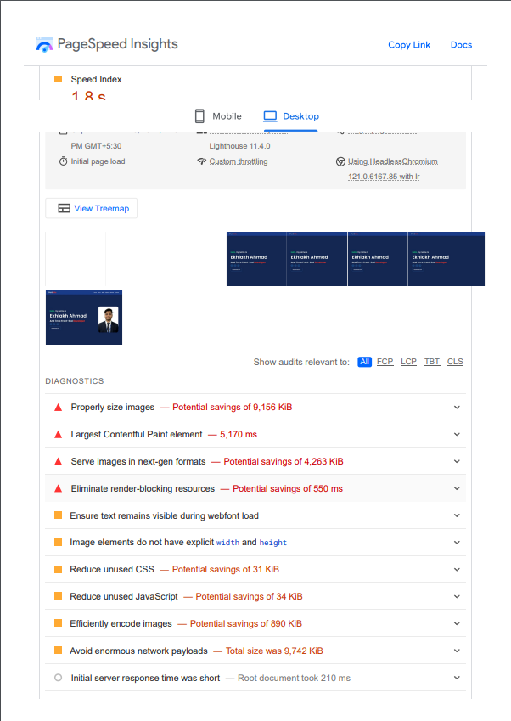

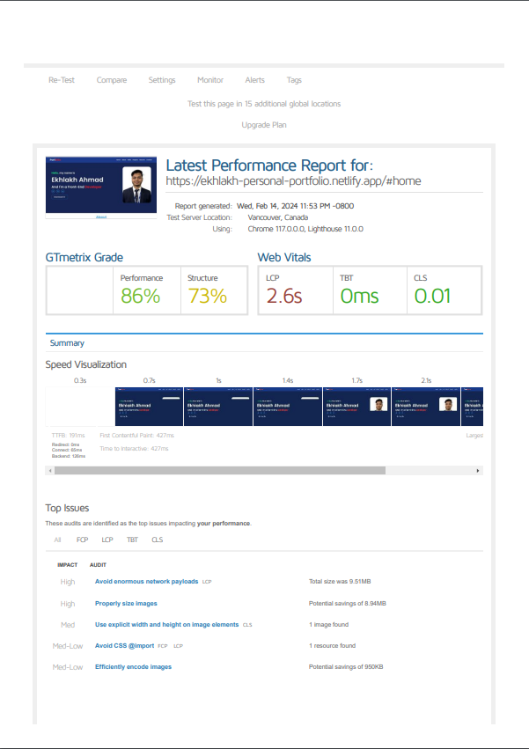**GTmetix Grade Without Optimization**

**Google Analytics Without Optimization**

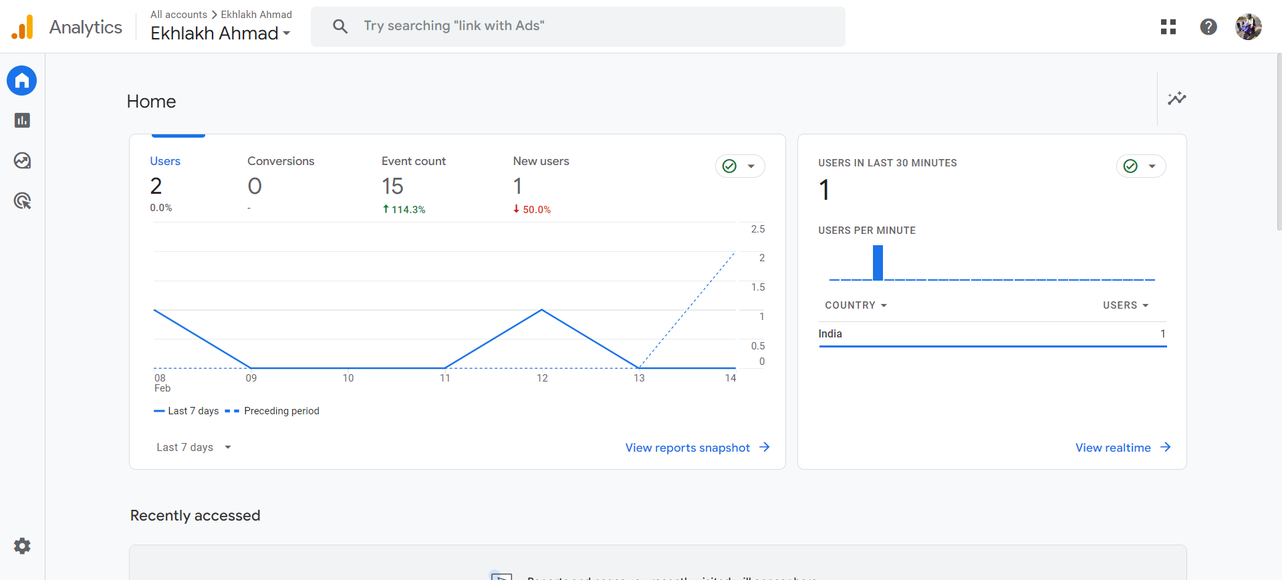

**Use UnCSS Without Optimization**

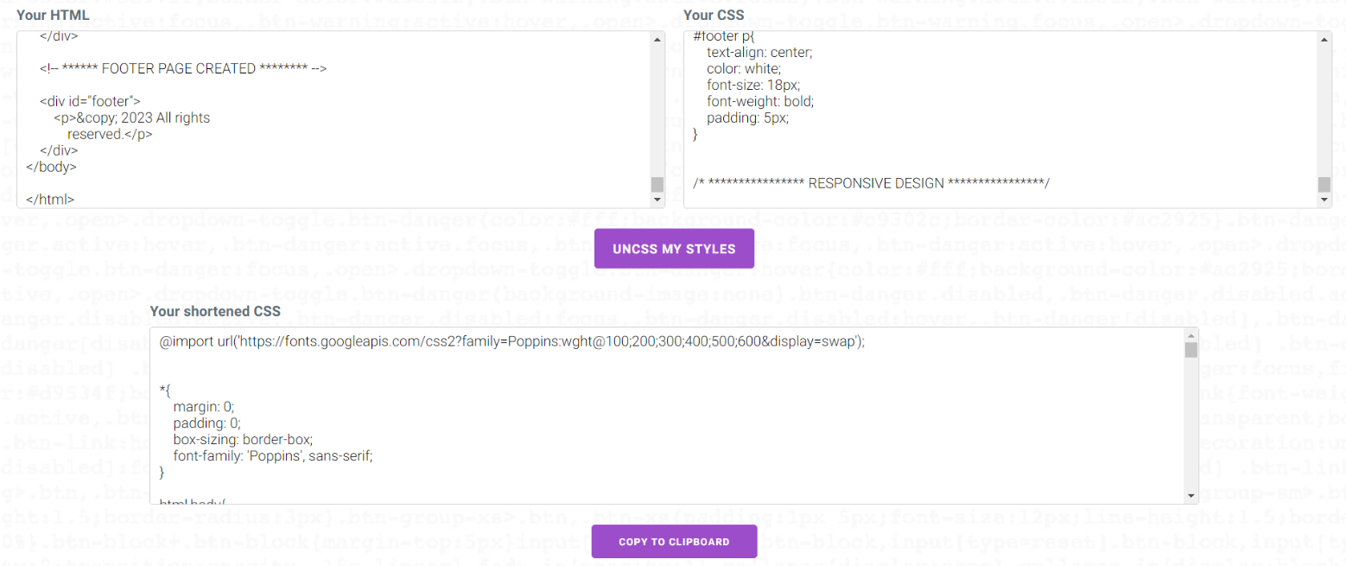

**GTmetrix Grade With Optimization**

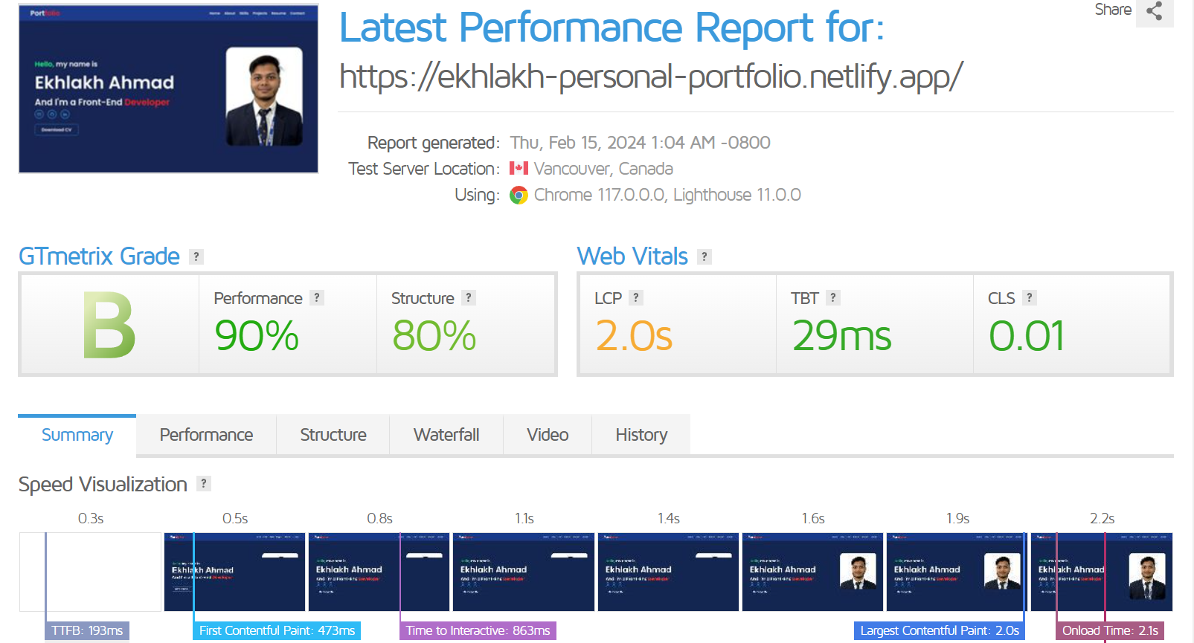

**Page Speed Without Optimization**

